Report
Of
SUMMER INTERNSHIP

Submitted
To
School of Computer Science and Engineering
IILM University, Greater Noida, U.P.

In partial fulfilment of the requirement of degree of
B.Tech CSE



By
Roll Number of Student: 2410031609
Name of Student: PALAK UPADHYAY
Batch: B.TECH cse(3cse16)

2026-27

CANDIDATE’S DECLARATION

I, Palak Upadhyay do hereby declare that the internship report titled “Topic” has been completed by me to fulfil the requirement for the award of the degree of Bachelor of Technology in CSE. All the references have been quoted and I have not taken as such any material from any other source. I affirm to you that this report is my own and has not been submitted to any other institute for any degree/diploma requirement and further I shall be solely responsible for any kind of copyright violation in this regard.

Signature
Student Name Palak Upadhyay
Roll No. 2410031609

ACKNOWLEDGEMENT

I am using this opportunity to express my gratitude to everyone who supported me throughout the Internship Program. I am thankful for their aspiring guidance, invaluably constructive criticism and friendly advice during this work. I am sincerely grateful to them for sharing their truthful and illuminating views on a number of issues related to this work.
I express my gratitude to my parents for their blessings.

Signature
Student Name: Palak Upadhyay
Roll No.._2410031609

Chapter No. | Chapter Name | Page Nos.
 | Cover Page | ---1-
1. | Candidate’s Declaration | 2
2. | Acknowledgment | 3
3. | Internship Completion Certificate | 4
4. | Project Description  4 .1 Introduction  4.2 Organization Profile  4.3 Problem Statement  4.4 Project Objectives  4.5 Scope of the Project  4.6 Technologies and Tools Used  4.7 System Architecture  4.8 Methodology  4.9 Expected Outcomes  4.10 Certificates of completion and other communication mail proof must be attached | 6
5. | Bibliography/References | 10

INTERNSHIP OFFER LETTER
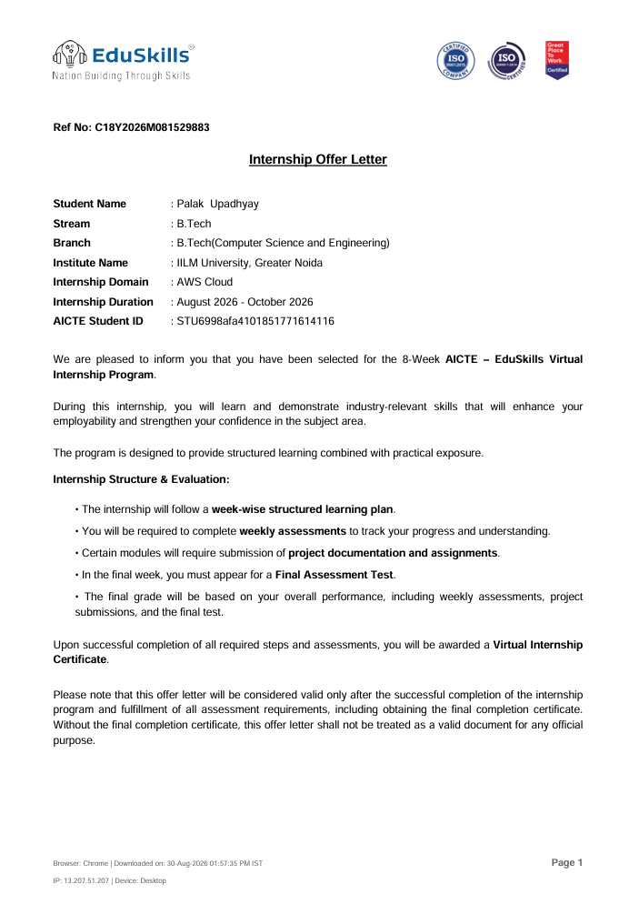
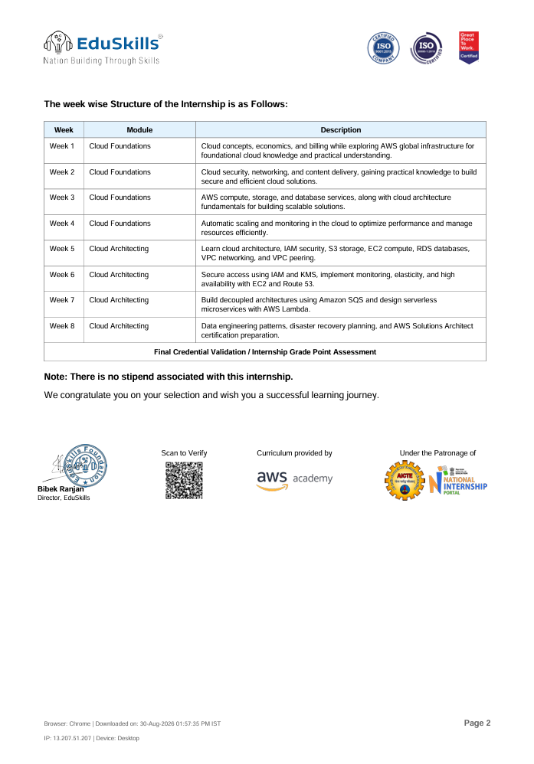

PROJECT DESSCRIPTION
4.1 Introduction
The EduSkills internship provided an opportunity to gain practical exposure to industry-oriented technologies and concepts. During the internship, the project was designed to apply the knowledge gained through training to a practical technical problem.
The project focused on understanding the complete development and implementation process, including requirement analysis, technology selection, system design, implementation, testing, and documentation. The internship helped in developing technical skills as well as problem-solving, analytical, and professional communication skills.
The project also provided hands-on experience with modern tools and technologies and helped bridge the gap between academic learning and real-world industry requirements.

4.2 Organization Profile
EduSkills Foundation is an organization focused on providing students with industry-relevant learning opportunities through internships, training programs, and skill-development initiatives. The organization works with academic institutions and technology partners to provide learners with practical exposure to emerging technologies.
EduSkills offers internship and training opportunities in areas such as Artificial Intelligence, Machine Learning, Cloud Computing, Cyber Security, Networking, Data Science, and other technology domains.
The internship program provides students with structured learning resources, practical assignments, assessments, and opportunities to work on technology-oriented projects. Through these programs, students can develop technical competencies and gain an understanding of professional working environments.

4.3 Problem Statement
Students often have theoretical knowledge of technical concepts but limited opportunities to apply that knowledge to practical projects. This creates a gap between academic education and industry requirements.
The main problem addressed through this internship project was to develop a practical understanding of the selected technology and implement the concepts learned during the internship in a structured project.
The project aimed to provide a practical solution while following proper development, testing, documentation, and security practices.

4.4 Project Objectives
The major objectives of the project were:
- To understand the fundamentals of the selected technology and its practical applications.
- To apply theoretical concepts to a real-world technical problem.
- To develop hands-on experience with industry-relevant tools and technologies.
- To understand the different stages of project development.
- To improve programming, analytical, and problem-solving skills.
- To perform testing and identify possible errors or limitations.
- To document the project development process systematically.
- To gain professional experience through the EduSkills internship program.

4.5 Scope of the Project
The scope of the project includes the study, design, development, and testing of the proposed technical solution.
The project can be used as a foundation for further development and improvement. Depending on the requirements, additional features, security mechanisms, automation, or advanced technologies can be integrated into the system in the future.
The project also provides an opportunity to understand how technical concepts learned during the internship can be applied to practical situations.

4.6 Technologies and Tools Used
The following technologies and tools were used during the internship/project:
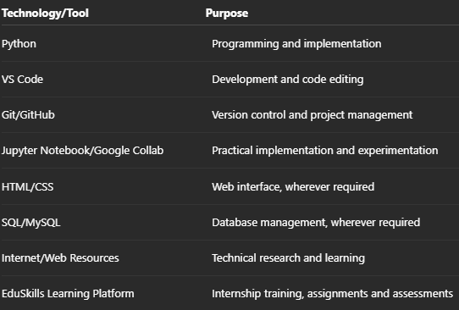
Note: Technologies can be modified according to the actual EduSkills internship/project completed.

4.7 System Architecture
The proposed system follows a structured architecture consisting of multiple stages. The basic architecture includes:
Input → Processing → Implementation → Testing → Output
Architecture Components
- Input Layer:
Collects the required user data, files, parameters, or other project inputs.
- Processing Layer:
Processes the input using the selected programming language, algorithms, and technologies.
- Application/Logic Layer:
Performs the main operations and implements the required functionality of the project.
- Database layer Layer:
Stores and retrieves information wherever database functionality is required.
- Testing Layer:
Tests the developed system to identify errors, bugs, and unexpected behavior.
- Output Layer:
Provides the final result or required information to the user.
This architecture allows the system to be developed in a systematic and modular manner.

4.8 Methodology
The project was developed using a systematic methodology consisting of the following stages:
Step 1: Requirement Analysis
The project requirements were studied and the problem was analyzed to understand the expected functionality.
Step 2: Technology Selection
Suitable programming languages, frameworks, tools, and platforms were selected according to the project requirements.
Step 3: System Design
The overall workflow, system architecture, modules, and data flow were planned.
Step 4: Implementation
The proposed solution was implemented using the selected technologies and tools.
Step 5: Testing
Different test cases were performed to identify errors and verify that the system produced the expected results.
Step 6: Debugging and Improvement
Errors identified during testing were analyzed and corrected. The system was refined to improve its performance and reliability.
Step 7: Documentation
The project development process, technologies, methodology, results, and learning outcomes were documented in the internship report.

4.9 Expected Outcomes
The expected outcomes of the project and internship were:
- Practical understanding of industry-relevant technologies.
- Improved programming and technical skills.
- Better understanding of software/project development methodologies.
- Ability to analyze and solve technical problems.
- Experience in using development and documentation tools.
- Understanding of testing and debugging processes.
- Improved professional communication and teamwork skills.
- Successful completion of the assigned internship activities and project.
- Development of a foundation for future technical projects and career opportunities.

5 - BIBLIOGRAPHY
- EduSkills Foundation, EduSkills Internship and Learning Resources, EduSkills Foundation.
- Python Software Foundation, Python Documentation, Python Official Documentation.
- Microsoft, Visual Studio Code Documentation, Visual Studio Code Documentation.
- GitHub, GitHub Documentation – Version Control and Collaboration, GitHub.
- Oracle, MySQL Documentation, MySQL Reference Manual.
- W3Schools, HTML, CSS, Python and SQL Tutorials, Online Learning Resources.
- GeeksforGeeks, Computer Science and Programming Resources, Online Technical Reference.
- TutorialsPoint, Programming and Software Development Tutorials, Online Learning Resources.
- Google Colab, Colaboratory Documentation, Google Research.
- EduSkills Internship Training Material, Course Content, Assignments, Assessments and Project Resources, EduSkills Foundation.
- Relevant technical articles, research papers, documentation, and online resources consulted during the development and implementation of the project.

